西赛尔

XSE-903-C production bed

Instruction for use

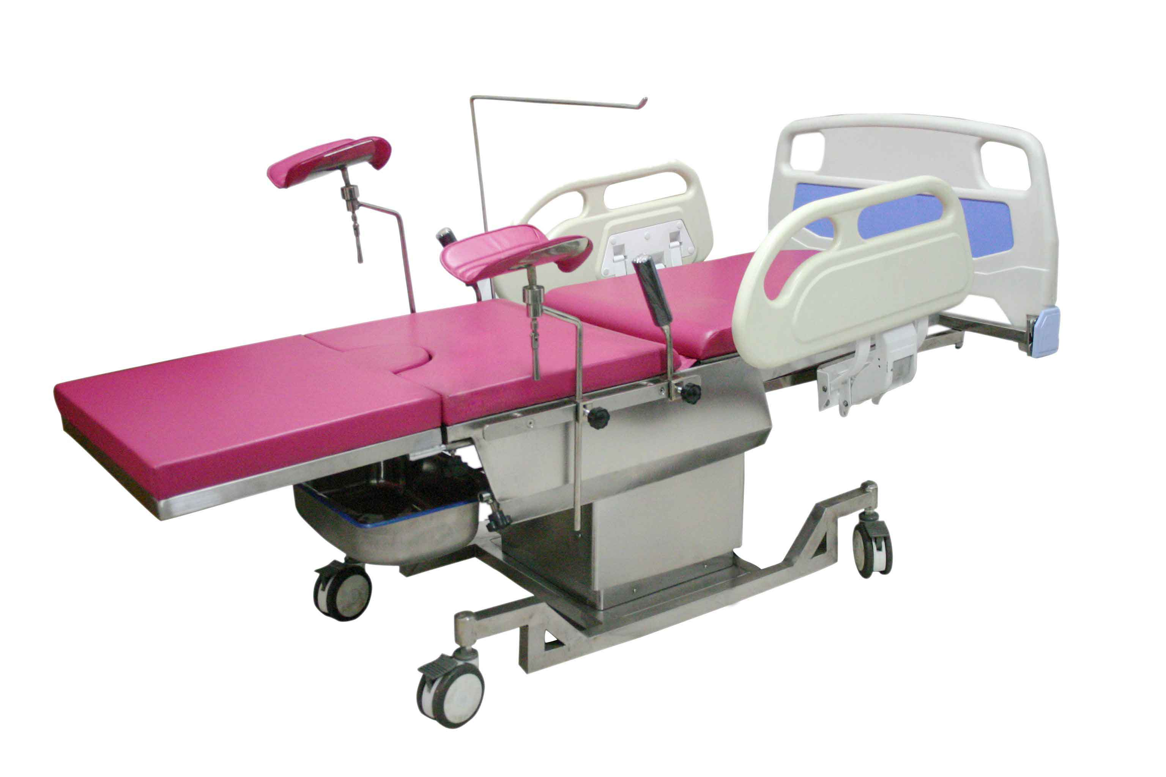

Harbin west self medical equipment co., LTD

No.26 Spring Street, Nangang District, Harbin Postal Code: 150030 Tel / Fax: (0451) 85923767

XSE-903-C production bed
One, Overview:
This product is the latest research and development of modern obstetrics and gynecology comprehensive products, is set, childbirth, see a doctor, examination, surgery, in an integrated production and sick bed.

Two，composition
1、Machines, seats and beds, lifts
2、Back plate and buttocks part
3、Detachable leg tray section 4、Leg pallet section
5、Handle and armrest part 6、Pedal part
7、Drip rack part 8、Dirt basin part
9、Four ABS universal castors
10、Foldable ABS guardrail

Three, the main technical indicators
1、Basic requirement: Apply to any childbirth, diagnosis, examination
2、function：All electric control, with guardrail and separate shift pedal; bed equipped with waterproof pad
3、Bed size:≥1850mm×600mm
4、Auxiliary board size: ≥560mm×520mm, The auxiliary is hidden, but for the stainless steel surface can be detachably connected with the mattress
5、Parturition, ascending and falling:
≥750mm-1000mm
6、Folding angle of back plate：≥72°
7、Seat plate up angle：≥15°
8、noise：Mute，≤40dB
9、Head low angle feet high angle：have
10、Head high angle, feet low angle：have
11、Left and right side：have
12、Fixation of the body and legs: have
13、Head frame, arm plate, and fixed：have

Four, operation guide
1, manual controller can control a variety of actions, etc..
2, the bed is equipped with three different detachable legs, suitable for different purposes.
3, dirt basin can catch dirt, remove.
4, universal leg support height, angle, front and rear position, left and right distance can be adjusted.
5, birth bed has four solid ABS casters, the wheel has a brake function.
6, the arm board can rotate 80 DEG side, to provide convenience to users such as blood pressure measurement.

Five, maintenance and maintenance and other matters needing attention
a) periodic lubrication of the rotating parts and sliding parts.
b) use to hear the same noise immediately stop, be troubleshooting before use.
c) in case of non-rise does not decrease the problem, first find the power supply, power plug, fuse, lights and other circuits to see whether the limit, troubleshooting can be normal operation.
d) before use, according to the conventional disinfection of medical devices, disinfection of the bed.

Six. This product is made of stainless steel

Seven, contact information
Tel: 0451-85923767
Fax: 0451-85923767
Address: Nangang District, Harbin Spring Street on the 26th
Zip code: 150030

Harbin west self medical equipment co., LTD

